ASSIGNMENT 21

Name : Akanksha Joshi

Roll No : B038

Batch : 3

Div : BTech CS B

--------------------------------------------------------------------------------------------------------------------------

Q.The "Variety Retail Store" sells diﬀerent varieties of Furniture to the customers. The list of furniture available with its respective cost is given below:

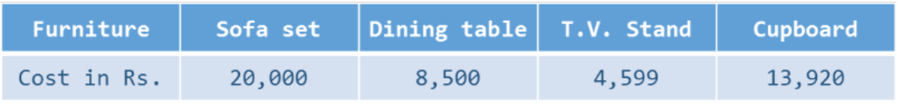

The furniture and its corresponding cost should be stored as a list. A customer can order any furniture in any quantity (the name and quantity of the furniture will be provided). If the required furniture is available in the furniture list(given above) and quantity to be purchased is greater than zero, then bill amount should be calculated.

In case of invalid values for furniture required by the customer and quantity to be purchased, display appropriate error message and consider bill amount to be 0. Initialize required furniture and quantity with diﬀerent values and

test the results.

Write a Python program to calculate and display the bill amount to be paid by the customer based on the furniture bought and quantity purchased.

Hint – Create two diﬀerent lists for 'Furniture' and 'Cost'. Indices of two lists should be matched to retrieve the cost of a particular furniture.

Source Code

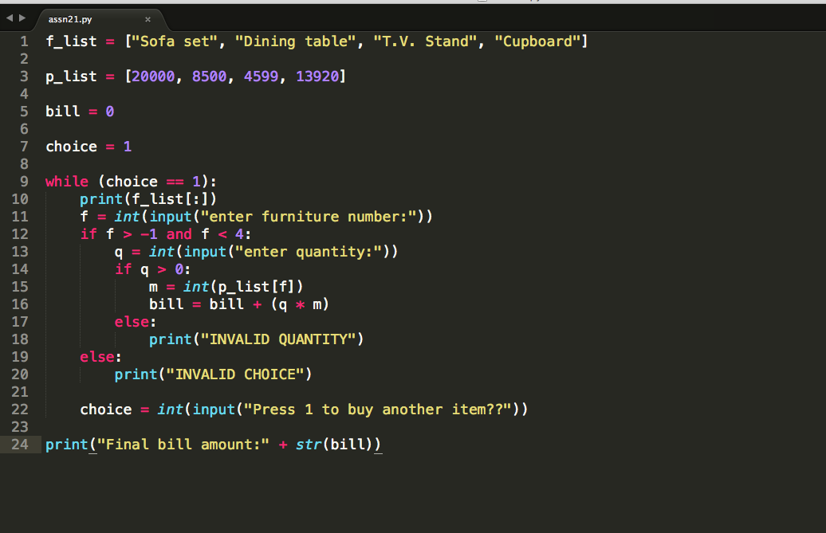

Output

['Sofa set', 'Dining table', 'T.V. Stand', 'Cupboard']

enter furniture number:3

enter quantity:4

Press 1 to buy another item??1

['Sofa set', 'Dining table', 'T.V. Stand', 'Cupboard']

enter furniture number:2

enter quantity:1

Press 1 to buy another item??0

Final bill amount:60279